# Test Document for CR593-Report required to extract data of unmatched purchase receipt

# Testing for Supplier SUPS10688 - SUPS10689,

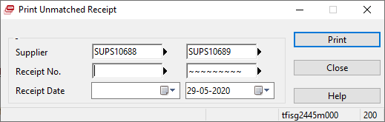

Result:

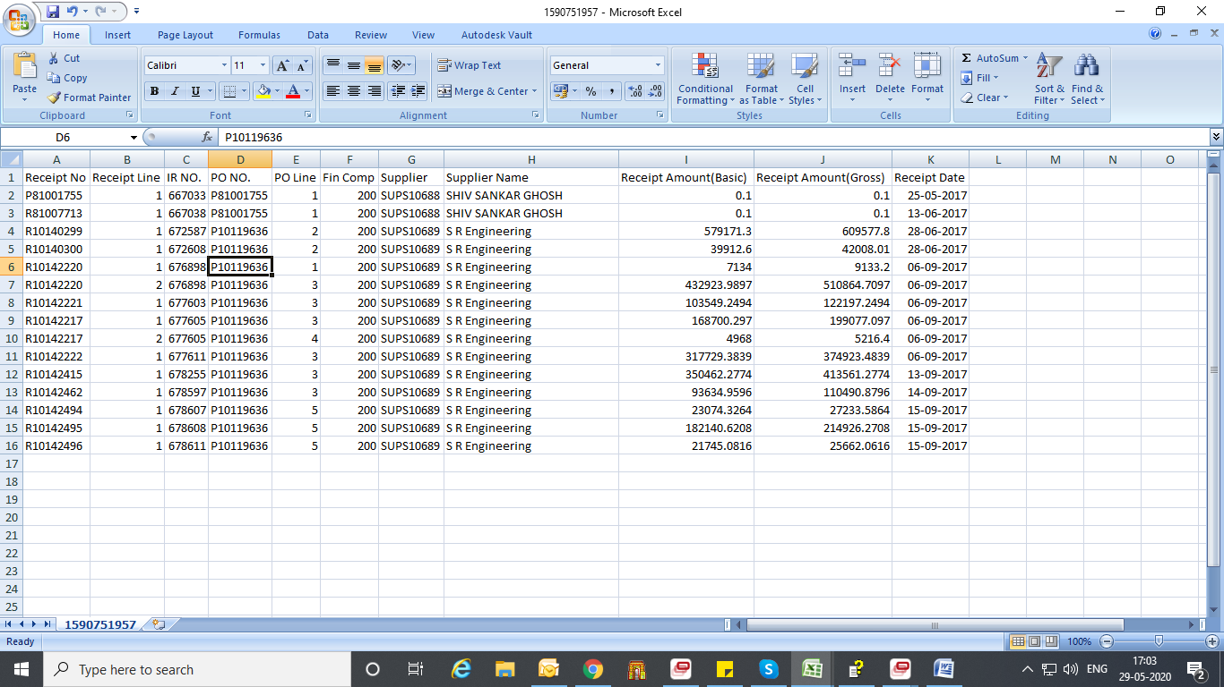

Now testing for Receipt no P81001755 - P81001760

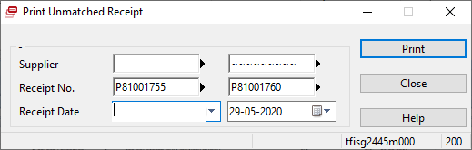

Result:

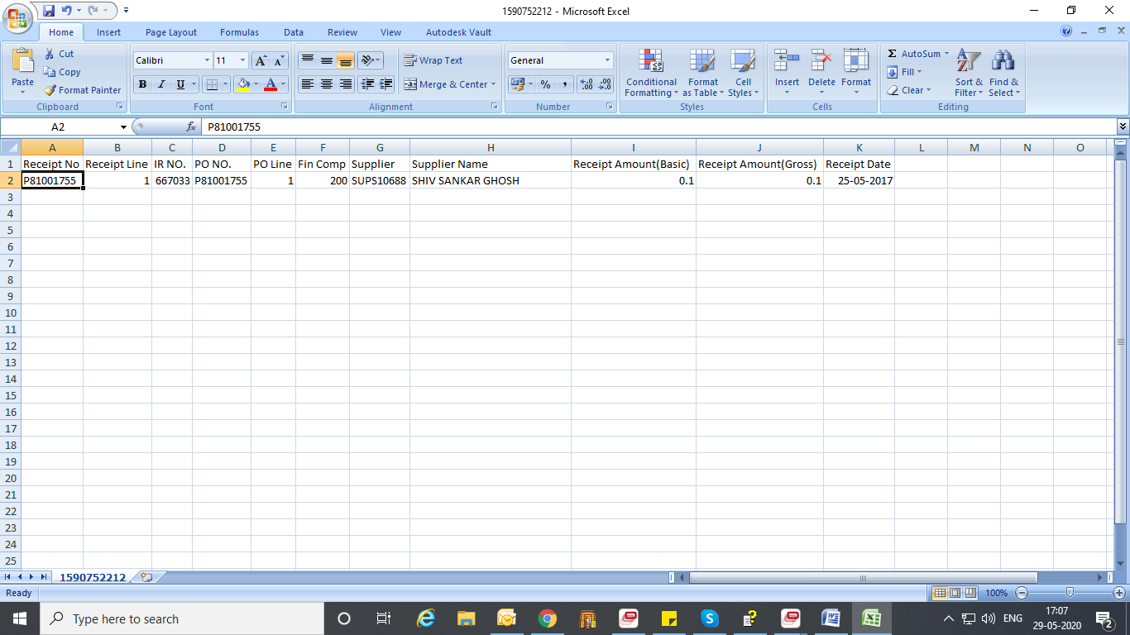

Now testing for Receipt date 15-01-2019– till now

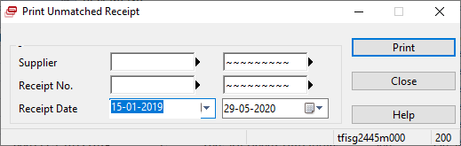

Result:

